Microsite 2014 Upgrades

In an effort to simplify the microsite navigation, add in some new features, and provide consistency throughout the chapter microsites will be updated during the month of January.
- Site Navigation – Currently each microsite typically has the menu items Directory, Discussions, Libraries and Blogs and under these menu items are a large number of pages. Through analysis and studies vendor has identified that the majority of these pages are not visited and too many choices are confusing to user.
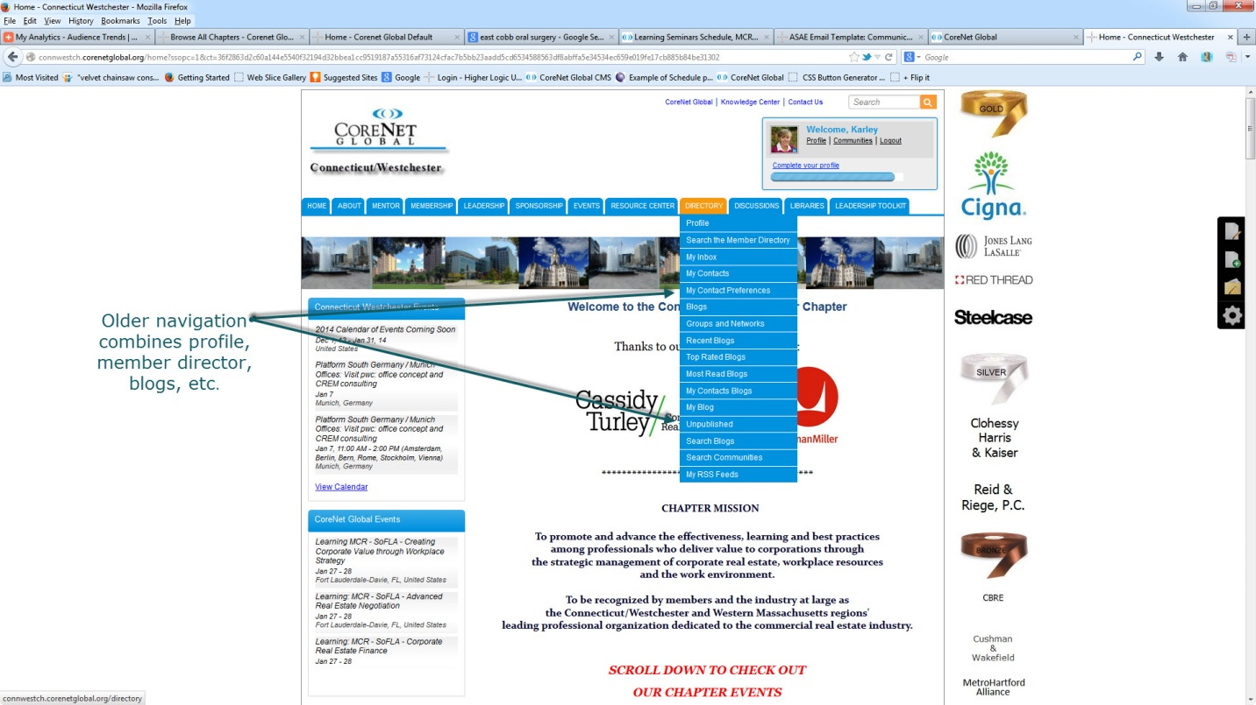
- New site navigation will include My Profile, Directory and Resources with a limited number of pages under these items.
- My Profile. Pages under this item include Profile, My Communities, My Contacts, My Subscriptions. Additionally, on the Profile Page they can access any community content they have contributed – blog posts, files, messages.
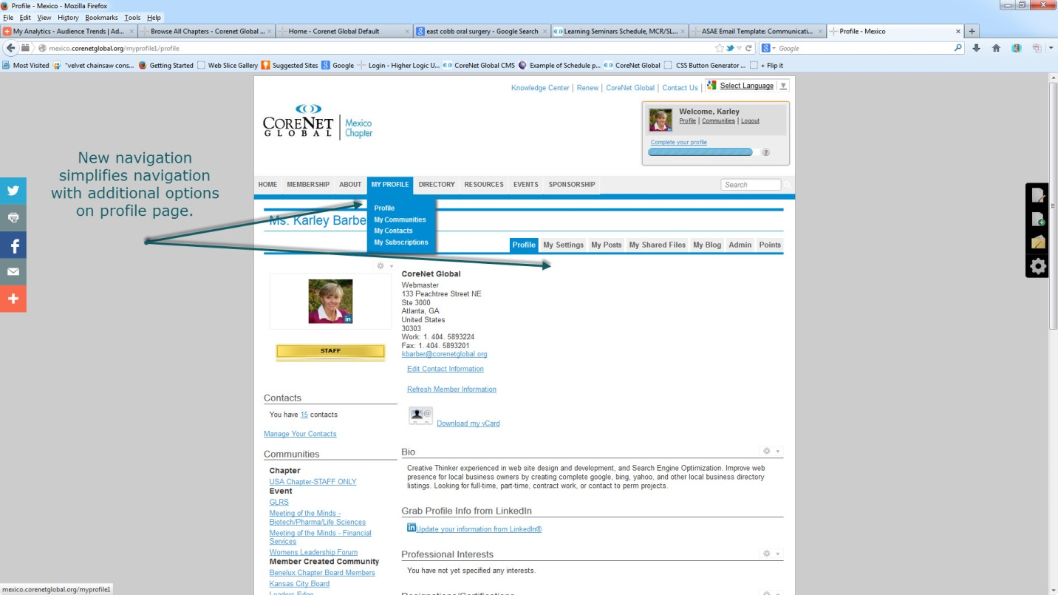
- Directory. Searching member directory both in chapter and total membership. User can do a basic or advanced search.
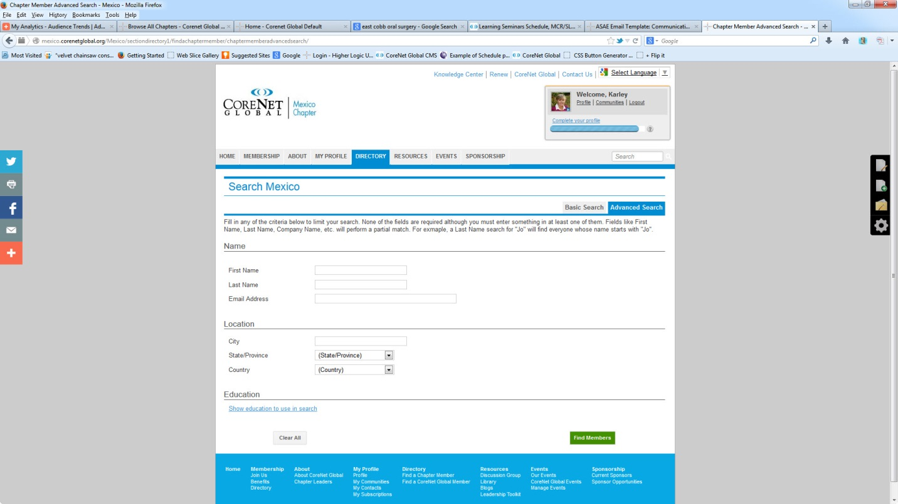
- Resources. Display library, blogs and discussions for chapter.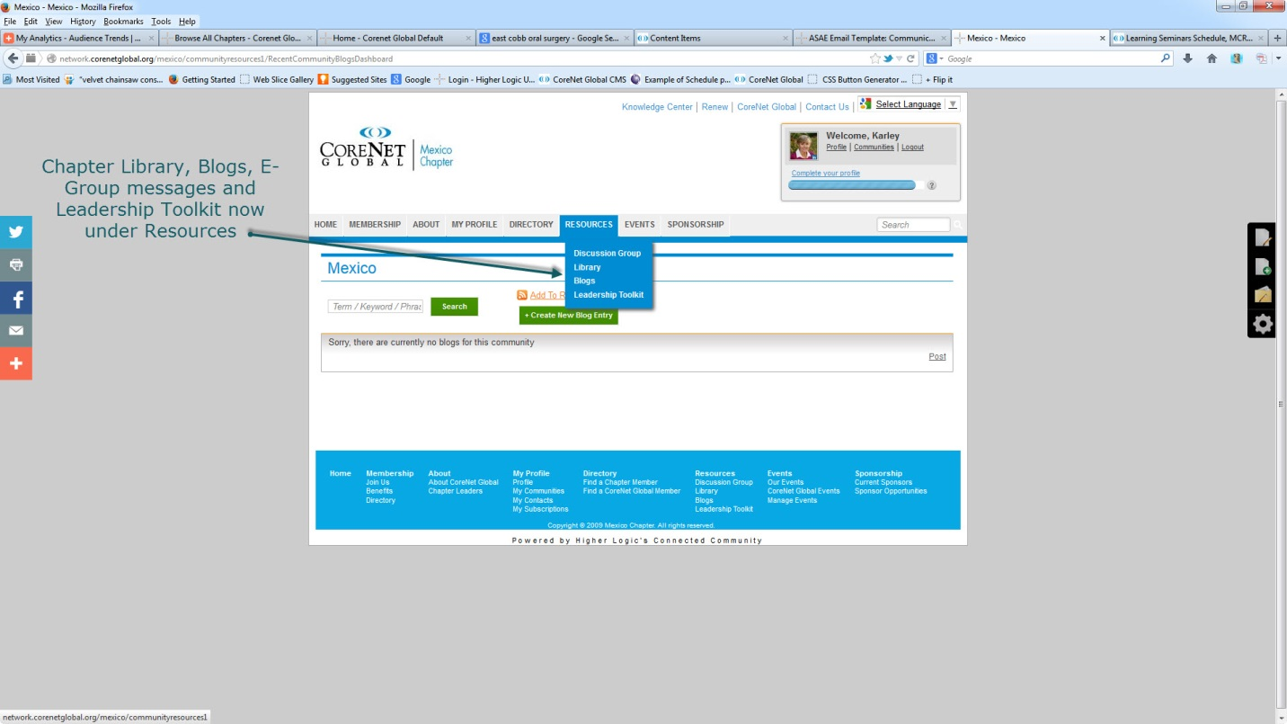
- New functionality includes social media sharing icons on left and Google Translator function top right of page. Admin functions now on right.
